Result and Code for Question E and F

Assumption: no management fees and transaction fees; the expected return, volatility, correlation, and investment criteria will not change for five years; the year is the unit of account → get rid of compounding.

e) 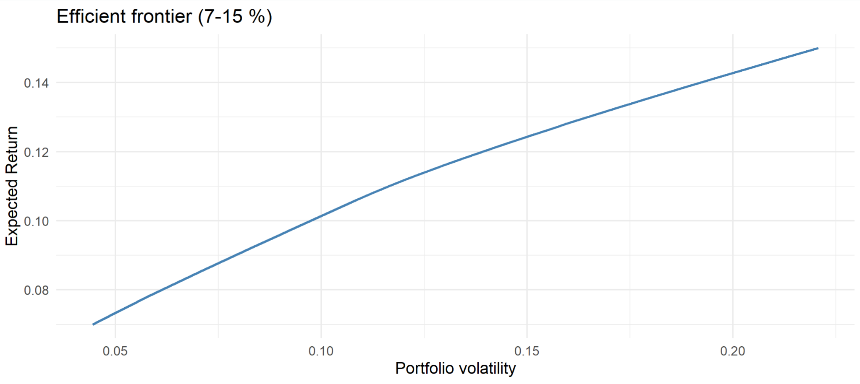

Finding:

It is a Capital Allocation Line (linear line) since it mixes a risk-free asset.

8% portfolio:

This portfolio has a balanced approach with:

Heavier investment in Kool Movies, which has the lowest volatility (2.5%)

Moderate positions in Happy Tech (9% volatility) and Risky Mining (25% volatility)

No allocation to GIC, likely due to its low return despite being a risk-free investment.

At 8% expected return, the optimizer prefers low-volatility stocks(especially Kool Movies), avoiding GIC because, although it's safe, its 2.5% return drags down the overall return potential.

14% portfolio:

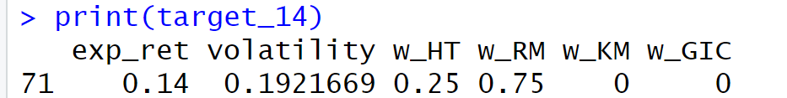

This is a high-risk, high-return strategy:

Heavy exposure to Risky Mining, which has the highest volatility (25%) but the highest annual returns (16%).

Moderate exposure to Happy Tech

Complete exclusion of Kool Movies and GIC

To push the return to 14%, the optimizer leans hard into the risky stock. Kool Movies is excluded because its return (5%) is too low to help meet the target.

Expected Volatility Comparison:

8% portfolio volatility: ~6.13%

14% portfolio volatility: ~19.22%

The 14% portfolio’s volatility (19.22%) is slightly below Risky Mining’s volatility (25%). Even though 75% is in Risky Mining, the 25% in Happy Tech (5% volatility) still contributes to total volatility. However, the diversification benefit is limited here because the correlation (0.15) isn’t strong enough to significantly reduce risk.

The 8% portfolio volatility is much lower, thanks to including a significant amount of Kool Movies, whose volatility is the lowest at 2.5%.

Why neither GIC:

GIC is optimal for capital preservation, but inefficient for growth-focused portfolios aiming at 8% or 14% return.

Suggested portfolio:

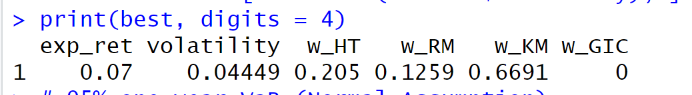

Choose it due to the lowest volatility.

Value-At-Risk:

If we use this portfolio,



It means there is 5% chance that we will lose more than $3279 in one year.

f) To meet the original goal of the company, which is more than 7% annual return for this re-investment, here is the new portfolio:

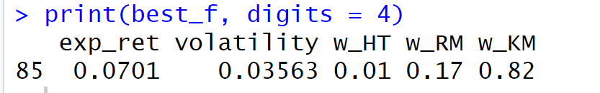

This portfolio is the one that still meets the requirement and has the lowest volatility.

Since my previous portfolio does not include any GICs, we will disregard this stock. We know that capital invested in the GIC cannot be withdrawn until the end of the 5 years, but we only have 3 years remaining for this five-year portfolio.

Code:

library(quadprog)

library(ggplot2)

#q-e

assets_eq <- c("Happy_Tech", "Risky_Mining", "Kool_Movies")

mu_eq <- c(0.08, 0.16, 0.05)

sigma_eq <- c(0.09, 0.25, 0.025)

corr_eq <- matrix(c( 1.0, 0.15, 0.40,

0.15, 1.0, -0.05,

0.40,-0.05, 1.0 ), 3, 3, byrow = TRUE)

Sigma_eq <- diag(sigma_eq) %*% corr_eq %*% diag(sigma_eq)

r_GIC <- 0.025

solve_min_var_eq <- function(target_mu){

prem_eq <- mu_eq - r_GIC # equity excess returns

ones3 <- rep(1, 3)

# Dmat and dvec for ½ wᵀΣw

Dmat <- 2 * (Sigma_eq + diag(1e-10, 3)) # tiny ridge to ensure PD

dvec <- rep(0, 3)

# --------- constraint matrix (Aᵀ w ≥ b) ----------

# 1) sum w = s (equality) → a₁ᵀ = ones3

# 2) premᵀw = target-r_GIC (equality)→ a₂ᵀ = prem_eq

# 3) wᵢ ≥ 0 (inequalities) → diag(3)

Amat <- cbind(ones3, prem_eq, diag(3))

bvec <- c(1, target_mu - r_GIC, rep(0, 3))

w_eq <- solve.QP(Dmat, dvec, Amat, bvec, meq = 2)$solution

w_eq / sum(w_eq) # rescale so Σw_eq = 1

}

targets <- seq(0.07, 0.12, by = 0.001)

results <- do.call(rbind, lapply(targets, function(tgt){

w_eq <- tryCatch(solve_min_var_eq(tgt), error = function(e) return(NULL))

if (is.null(w_eq)) return(NULL)

w_GIC <- 1 - sum(w_eq) # residual to GIC

exp_ret <- r_GIC + sum((mu_eq - r_GIC) * w_eq)

volatility <- sqrt(t(w_eq) %*% Sigma_eq %*% w_eq)

data.frame(exp_ret, volatility,

w_HT = w_eq[1],

w_RM = w_eq[2],

w_KM = w_eq[3],

w_GIC)

}))

ggplot(results, aes(x = volatility, y = exp_ret)) +

geom_line(linewidth = 1.1, colour = "steelblue") +

labs(x = "Portfolio volatility",

y = "Expected Return",

title = "Efficient frontier (7–12 %)") +

theme_minimal(base_size = 14)

best <- results[which.min(results$volatility), ]

print(best, digits = 4)

# 95% one-year VaR (Monte Carlo) - use lowest volatility

n_sim <- 100000

mu <- best$exp_ret

sigma <- best$volatility

initial_value <- 1e6

set.seed(123)

simulated_returns <- rnorm(n_sim, mean = mu, sd = sigma)

simulated_values <- initial_value * (1 + simulated_returns)

simulated_losses <- initial_value - simulated_values

VaR95_mc <- quantile(simulated_losses, probs = 0.95)

cat(sprintf("\nMonte Carlo 95%% one-year VaR: $%0.0f\n", VaR95_mc))

#q-f

mu_f <- c(0.05, 0.12, 0.06)

sigma_f <- c(0.05, 0.15, 0.03)

corr_f <- matrix(c(

1, 0.2, 0.35,

0.2, 1, 0,

0.35, 0, 1

), nrow = 3, byrow = TRUE)

cov_f <- diag(sigma_f) %*% corr_f %*% diag(sigma_f)

step <- 0.01

w_HT <- seq(0, 1, by = step)

results_f <- data.frame()

for (w1 in w_HT) {

for (w2 in seq(0, 1 - w1, by = step)) {

w3 <- 1 - w1 - w2

weights <- c(w1, w2, w3)

exp_ret <- sum(weights * mu_f)

volatility <- sqrt(t(weights) %*% cov_f %*% weights)

if (exp_ret > 0.07) {

results_f <- rbind(results_f, data.frame(

exp_ret = exp_ret,

volatility = as.numeric(volatility),

w_HT = w1,

w_RM = w2,

w_KM = w3

))

}

}

}

best_f <- results_f[which.min(results_f$volatility), ]

print(best_f, digits = 4)